**Density of regular shaped objects**

**AIM:** Determine the density of regular shaped objects.

**EQUIPMENT:**

* Non-porous objects with regular shape, made from different materials
* Protector triangle
* Scale
* Calculator

**THEORY:**

The density is a property of a substance and is different for each material. The density can be calculated using the following formula: $ρ= \frac{m}{V}$

* $ρ=$ density in $g/{{cm}^{3}}$
* $m=$ mass in $g$
* $V$ = Volume in ${cm}^{3}$

**METHOD:**

1. Choose one of the regularly shaped objects available.
2. Measure the mass of the object and record the value in the table below.
3. Record the dimensions of the object (length, height, width) and determine its volume. Write the value in the table.
4. Calculate the density of the object using the formula above.
5. Try to name the material of the object, using the table from your textbook.

**RESULTS:**

|  |  |  |  |  |
| --- | --- | --- | --- | --- |
| Object | Mass (g) | Volume (cm3) | Density (g/cm3) | Material |
|  |  |  |  |  |
|  |  |  |  |  |
|  |  |  |  |  |
|  |  |  |  |  |

**Density of irregular shaped objects**

**AIM:** Determine the density of irregular shaped objects.

**EQUIPMENT:**

* Non-porous objects with irregular shape, made from different materials
* Measuring cylinder
* Water
* Scale
* Calculator

**THEORY:**

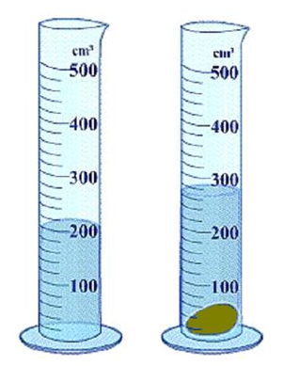The density is a property of a substance and is different for each material. The density can be calculated using the following formula: $ρ= \frac{m}{V}$

* $ρ=$ density in $g/{{cm}^{3}}$
* $m=$ mass in $g$
* $V$ = Volume in ${cm}^{3}$

The volume of displaced water is exactly the same as the volume of the object. Keep in mind that 1 mL = 1 cm3.

**METHOD:**

1. Choose one of the irregularly shaped objects available.
2. Record the mass of the object and write the value in the table below.
3. Fill the measuring cylinder with 50 mL of water. Write the volume down in the table.
4. Add the object to the water and record the volume in the table.
5. Calculate the volume of the object (Vobject = Vend – Vbegin)
6. Calculate the density of the object using the formula above.
7. Try to name the material of the object, using the table from your textbook.

**RESULTS:**

|  |  |  |  |  |
| --- | --- | --- | --- | --- |
| Object | Mass (g) | Volume (cm3) | Density (g/cm3) | Material |
|  |  |  |  |  |
|  |  |  |  |  |